FLOWCHART FOR TWITTER CLONE

**User Registration and Login:**

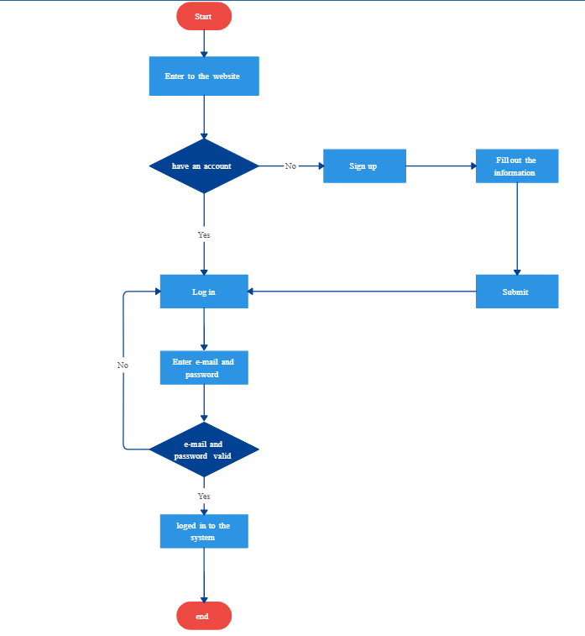

**Posting a Tweet:**

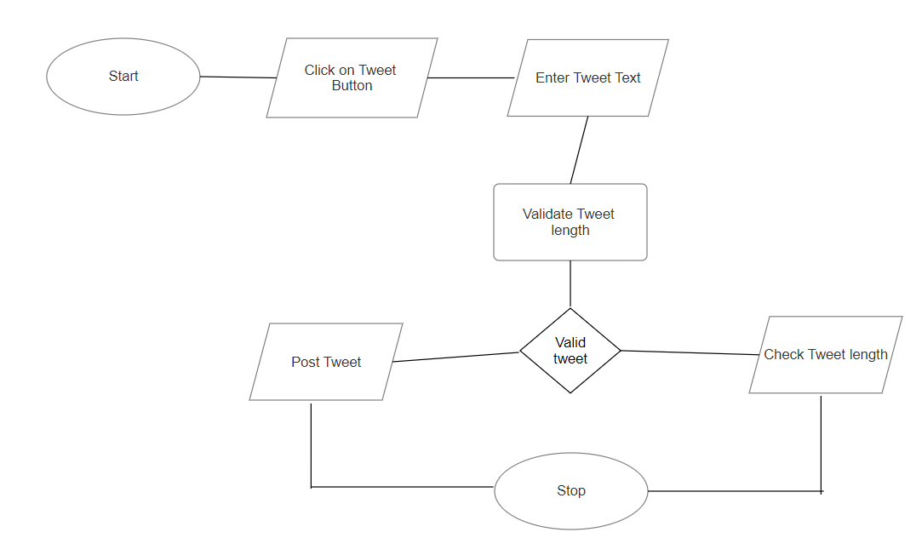

**Following/Unfollowing Users:**

